Definition :

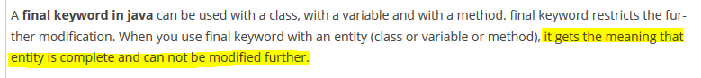

Final keyword can be used at three places

1. Variables
2. Methods
3. Classes

**Final variable:** Once variable declared as final then its value cannot be changed. It becomes constant.

**Final method:** when we want that method should not be overridden by any class. Then we make this method as final.

**Final class:** There are certain instances where don’t want to class to be extended by another classes. So in that we can make the class as ‘final’. So once the class is made final then this class cannot be extended by any other class.